**Bugg Report Forum**

Team Members:

1) Poojan Patel

2) Sanyasi Naidu Pyla

3) Sai Supreeth Segu

4) Vamshi Goud Valdas

5) Sai Krushi Annam

## ***PROJECT PROPOSAL***

**Context of the Project:**

We would like to create an efficient database management system for a platform where users can report various types of glitches(bugs) they have observed while playing a game. It’s nothing but a service request page in which we store information of developers and users of various games related to various platforms (pc, Xbox, ps4, mobile etc.,). Users will report bugs and developers will release the updates to fix bugs.

**SCOPE of the Project:**

We will be storing information about the below fields in the database which we will be creating:

* Different games played across the entire world.
* The gaming platforms like mobile, Xbox, desktop etc.
* The bugs information reported by the users for the specific games.
* The developers who will be fixing the bugs reported by the users.
* There will be an intermediate team between users and developers who filter the “‘good bugs” from the bugs which occurs due to incompatible system configurations(user end issues).
* This intermediate team even prioritize the bugs, depending upon the damage it is inflicting to the user experience.
* Intermediate team will escalate the “good bugs”(software bugs) to the Developer teams , where the resolution process begin.

This scope is not limited as we get along with the project we may add few required fields as on demand. This would be an high end scope for our project.

**OBJECTIVES:**

Main aim of our project is to create a Database platform that is convenient and efficient to use in storing and retrieving information about different bugs reported by various users, developers and the resolution status of those bugs. Not only those our project also facilitates the processes of maintaining, manipulating and the flexibility in updating and deletion of data when required.

## ***PROJECT ENVIRONMENT***

Database client : MySQL Workbench version 8.0.15

Database server: AWS RDS server

Web-application server: Nginx

Database connection: MySQL Connector/j8.0(JDBC Driver)

Programming Languages: Python, Java script, SQL, HTML, Css.

***HIGH LEVEL REQUIREMENTS***

### **Initial user roles**

|  |  |
| --- | --- |
| **User Role** | **Description** |
| customer | Raises request |
| Escalation engineer | Prioritize the bug and forward it to the concerned Developer |
| Developer | Fix the bug and releases the updates |

**Initial user story descriptions**

|  |  |
| --- | --- |
| **Story ID** | **Story description** |
| User1 | As a user, I want to raise a request for the bug observed in game |
| User2 | As a user, I want to Download an update |
| User3 | As a user, I want to check the status of created requests. |
| User4 | As a developer, I want to release an update |
| User5 | As an escalation engineer, I want to update the status of the request. |
| User6 | As a developer, I want to change the status of the request |
| User7 | As a Subscriber, I want to close the request. |

***HIGH LEVEL CONCEPTUAL DESIGN***

Entities:

User

Escalation engineer

Developer

Request

Game

Update

Relationships:

User<creates> Request

User<downloads> update

Escalation engineer <Updates> Request

Developer <releases> update

**SPRINT 1:**

Story ID Story description User1 As a Subscriber, I want to raise a request for the bug observed in game User2 As an escalation engineer, I want to update the status of requests. User3 As an escalation engineer, I want to prioritize the requests.

User4

As an escalation engineer, I want to create master Request and escalate to developer team.

User5

As an escalation engineer, i want to take ownership of the request User6 As a developer, I want to release updates.

User7

As a developer engineer, i want to take ownership of the request User8 As a developer, I want to update the status of the request. User9 As a Subscriber, I want to Download an update. User10 As a Subscriber, I want to check the status of created requests. User11 As a Subscriber, I want to close the request.

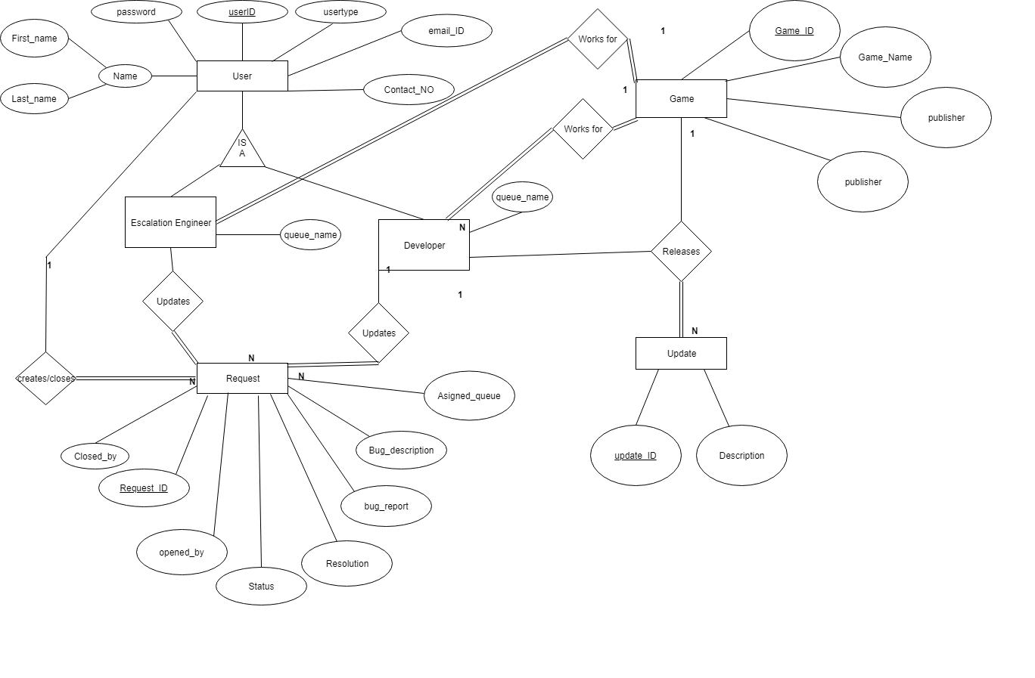

Conceptual Design:

Entity: USER(**Parent**)

**Attributes:**

user_ID[Simple/Atomic]

Password[Simple/Atomic]

user_type[Simple/Atomic]

Name[composite]

First_name

Last_name

Middle_name

email_ID[Simple/Atomic]

Contact_No[Simple/Atomic]

Primary key justification: Every user need to have unique **user_ID**, so it is a good primary key.

Entity: **Escalation engineer/Developer -**inherits attributes from User

Game_ID[Simple/Atomic]

Queue_name[Simple/Atomic]

Employee_ID

Primary key justification: Every Escalation engineer has unique **user_ID**, so it is a good primary key.

Entity: **Game**

**Attributes**:

Game_ID[Simple/Atomic]

Game_Name[Simple/Atomic]

publisher

Platform[Simple/Atomic]

Entity: **Request**

**Attributes:**

Request_ID[Simple/Atomic]

Opened_by[single_valued]

Assigned_queue[Simple/Atomic]

Status[Simple/Atomic]

Bug_type[Simple/Atomic]

Bug_description[Simple/Atomic]

Resolution_description[Simple/Atomic]

Closed_by[Simple/Atomic]

Entity: **Update**

**Attributes:**

update_ID[single valued]

released_by[Simple/Atomic]

Game_ID[Simple/Atomic]

Description[Simple/Atomic]

**Relationships:**

1. Escalation_engineer/Developer <works for> Game.

Relationship: many - to - many

Participation: engineer/developer and the game has total participation

In first sprint, we have assumed that each each developer/escalation engineer can work for only one game. But in this sprint we have thought about a case where, a group of developers working for a publisher can work for few games which are released under the same publisher.

Escalation engineer teams are third party teams which supports few games.

2. User <raises> request

Relation : one to many

Participation: User has partial participation

Request has total participation in this relationship

Since,a request won’t exist if not raised.

3. Developer <releases> update

Relation: one to many

Participation: Developer has partial participation

Update has total participation in this relationship

Here, we have assumed that a group of developers can work on an update but the update can be released by any one of them.Hence, making it a one to many relationship.

4. Escalation_engineer/developer <Manages> request

Relation : one to many.

Participation: Escalation engineer has partial participation

Request has partial participation in this relationship

A request can be closed only once and a user can close many requests.

**Logical Design:**

Table: **USER** primary key(user_ID)

user_ID

Password

user_type

First_name

Last_name

Middle_name

email_ID

Contact_No

Table: **Escalation engineer/Developer** primary key(Employee_ID)

Employee_ID[foreign key; references id of User table]

Game_ID[foreign key; references id of Game table]

Queue

Table: **Game** primary key**(**Game_ID**)**

Game_ID

Game_name

publisher

Platform

Table: **Request**

primary key(Request_ID,Opened_by,Owner_Ship,Game_ID,Closed_by)

Request_ID

Opened_by[single_valued][foreign key; references id of User table]

Owner_Ship[foreign key; references id of Escalation engineer table]

Game_ID[foreign key; references id of Game table]

Assigned_queue

Status

Bug_type

Bug_description

Resolution_description

Closed_by[foreign key; references id of Escalation engineer table]

Table: **Update** primary key(update_ID,released_by,Game_ID)

update_ID[single valued]

released_by[foreign key; references id of Escalation engineer table]

Game_ID[foreign key; references id of Game table]

Description

**Sprint 2:**

We have found out that it’s not efficient to keep users, escalation engineers and developers under one table **USER**.So, we have created separate tables in this sprint.

|  |  |
| --- | --- |
| **Story ID** | **Story description** |
| User1 | As a user, I want to raise a request for the bug observed in game |
| User2 | As a user, I want to Download an update. |
| User3 | As a user, I want to check the status of created requests. |
| user4 | As an escalation engineer i want to take ownership of a request. |
| User5 | As an Escalation engineer, I want to prioritize the request |
| User6 | As a developer, I want to take ownership of the request. |
| User7 | As a developer, I want to change the status of the request |
| User8 | As a User/developer/escalation engineer, I want to close the request. |
| User9 | As an escalation engineer i want to assign request to Developer team. |
| User10 | As a Developer, i want to release an update |
| User11 | As a developer /escalation engineer I work for a developer team/escalation engineer team. |

Conceptual Design:

Entity: **USER**

**Attributes:**

user_ID[Simple/Atomic]

Password[Simple/Atomic]

Name[composite]

First_name

Last_name

Middle_name

email_ID[Simple/Atomic]

Primary key justification: Every user need to have unique **user_ID**, so it is a good primary key.

Entity: **Escalation Engineer**

**Attributes:**

EscalationEngineer_ID[Simple/Atomic]

Password[Simple/Atomic]

Name[composite]

First_name

Last_name

Middle_name

email_ID[Simple/Atomic]

Primary key justification: Every Escalation Engineer need to have unique EscalationEngineer_ID, so it is a good primary key.

Entity : **Developer**

**Attributes:**

Developer_ID[Simple/Atomic]

Password[Simple/Atomic]

Name[composite]

First_name

Last_name

Middle_name

email_ID[Simple/Atomic]

Primary key justification: Every Developer need to have unique Developer_ID, so it is a good primary key.

Entity : **Escalation Team**

**Attributes:**

Escalation_Team_ID[Simple/Atomic]

Game_ID[Simple/Atomic]

Total_memebers[Simple/Atomic]

Primary key justification: Escalation_Team_ID uniquely define the Escalation Teams entity , so it is a good primary key.

Entity : **Developers Team**

**Attributes:**

Developer_Team_ID[Simple/Atomic]

Game_ID[Simple/Atomic]

Total_memebers[Simple/Atomic]

Primary key justification: Developer_Team_ID uniquely define the Developer Teams entity , so it is a good primary key.

Entity : **EscalationEngineer_Works_for**

**Attributes:**

EscalationEngineer_ID

Team_ID

Working_since

Primary key justification: EscalationEngineer_ID and Team_ID together uniquely define the EscalationEngineer_Works_for entity, so both together is a good primary key.

Entity : **Developer_Works_for**

**Attributes:**

Developer_ID

Team_ID

Working_since

Primary key justification: Developer_ID and Team_ID together uniquely define the Developer_Works_for entity , so both together is a good primary key.

Entity : **GAME**

**Attributes:**

Game_ID

Name

Platform

Publisher

Primary key justification: Every GAME need to have unique Game_ID, so it is a good primary key.

Entity : **Games_Played_by_User**

**Attributes:**

User_ID

Game_ID

Playing_since

Primary key justification: User_ID and Game_ID together uniquely define the Games_Played_by_User entity , so both together is a good primary key.

Entity : **Request**

**Attributes: Primary Key(**Request_ID)

Request_ID

Opened_by[single_valued][foreign key; references id of User table]

Owner_Ship[foreign key; references id of Escalation engineer table]

Assigned_Team_ID[foreign key; references id of Escalations team table]

Status

priority

Bug_type

Bug_description

Resolution_description

Closed_by[foreign key; references id of Escalation engineer table]

Primary key justification: Every REQUEST need to have unique Request_ID, so it is a good primary key.

Entity: **Bug_Update**

**Attributes: Primary key(**update_ID**)**

update_ID[single valued]

released_by[foreign key; references id of Escalation engineer table]

Game_ID[foreign key; references id of Game table]

Update_version

Description

Primary key justification: Every UPDATE need to have unique update_ID, so it is a good primary key.

**RelationShips:**

1. Escalation_engineer/Developer <works for> Escalation team/developer team.

Relationship: many - to - many

Participation: engineer/developer and the respective teams has total participation

In first sprint, we have assumed that each each developer/escalation engineer can work for only one game. But in this sprint we have thought about a case where, a group of developers working for a publisher can work for few games which are released under the same publisher.

So we have added new tables Developer team and Escalation team which supports only one game. We have mapped escalation engineer/developer to many teams.

2. User <raises> request

Relation : one to many

Participation: User has partial participation

Request has total participation in this relationship

Since,a request won’t exist if not raised.

3. Developer <releases>bug_ update

Relation: one to many

Participation: Developer has partial participation

Bug_update has total participation in this relationship

Here, we have assumed that a group of developers can work on an update but the update can be released by any one of them.Hence, making it a one to many relationship.

4. Escalation_engineer/developer <Updates> request

Relation : one to many.

Participation: Escalation engineer has partial participation

Request has total participation in this relationship

A request can be closed only once and a user can close many requests.

**LOGICAL DESIGN:**

Table: **USER primary key(**user_ID)

user_ID

Password

First_name

Last_name

Middle_name

email_ID

Highest_normal form- 4NF

Table:**Escalation Engineer Primary Key(**EscalationEngineer_ID**)**

EscalationEngineer_ID

Password

First_name

Last_name

Middle_name

email_ID

Table:**Developer Primary Key(**Developer_ID)

Developer_ID

Password

First_name

Last_name

Middle_name

email_ID

Table: **Escalation Teams Primary Key(**Escalation_Team_ID)

Escalation_Team_ID

Game_ID[foreign key, references to Game table]

Total_members

Highest Normal Form : 4NF

Table: **Developers Teams Primary Key(**Developer_Team_ID)

Developer_Team_ID

Game_ID[foreign key, references to Game table]

Total_members

Highest Normal Form : 4NF

Table:**EscalationEngineer_Works_for**

**Primary Key(EscalationEngineer_ID,Team_ID)**

EscalationEngineer_ID[foreign key, references to **Escalation Engineer** table]

Team_ID[foreign key, references to **Escalation Teams** table]

Working_since

Highest Normal Form : 4NF

Table:**Developer_Works_for** Primary Key(Developer_ID,Team_ID)

Developer_ID[foreign key, references to **Developer** table]

Team_ID[foreign key, references to **Developer Teams** table]

Working_since

Highest Normal Form : 4NF

Table:**GAME Primary Key(**Game_ID**)**

Game_ID

Name

Platform

Publisher

Highest Normal Form : 2NF

Name → {publisher}, due to presence of transitive dependency, the highest normal form achieved is 2NF. We can normalize it more but it will result in more unnecessary tables and so will be joints.

Table:**Games_Played_by_User Primary Key(**User_ID, Game_ID**)**

User_ID[foreign key; references id of user table]

Game_ID[foreign key; references id of Game table]

Playing_since

Highest Normal Form - 4NF

Table:  **Request Primary Key(**Request_ID)

Request_ID

Opened_by[single_valued][foreign key; references id of User table]

Owner_Ship[foreign key; references id of Escalation engineer table]

Assigned_Team_ID[foreign key; references id of Escalation engineer teams table]

Status

priority

Bug_type

Bug_description

Resolution_description

Closed_by[foreign key; references id of Escalation engineer table]

* Here anyone of the 3(Escalation Engineer, Developer, User) can close the Request, so that’s the reason the “Closed_by” attribute has foreign key references to 3 tables.

Highest Normal Form - 4NF

Table: **Bug_Update Primary key(**update_ID**)**

update_ID[single valued]

released_by[foreign key; references id of Developer table][Developer ID]

Game_ID_for_Update[foreign key; references id of Game table]

Update_version

Description

Bug_Request[foreign key; references id of Request table][Request_ID]

Highest Normal Form - 4NF

**SQL SCREENSHOTS**:

Select *from User;

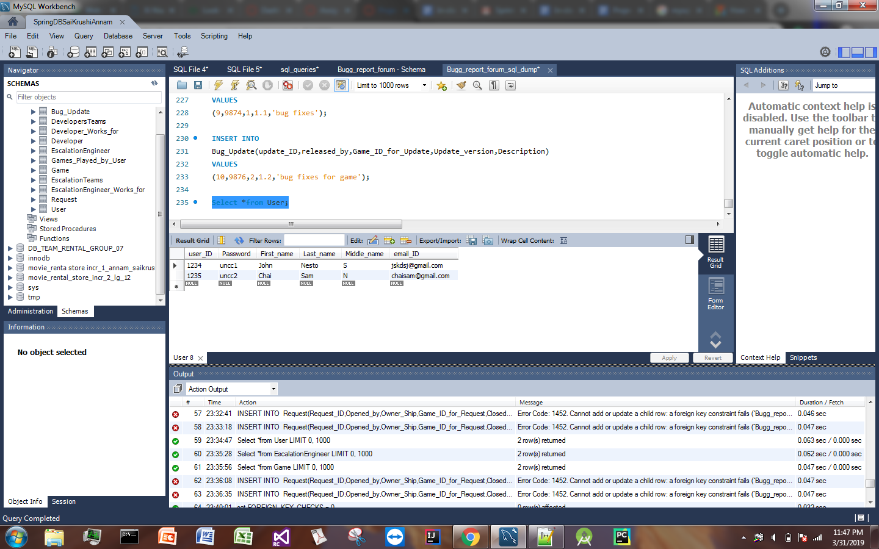

Select *from Request;

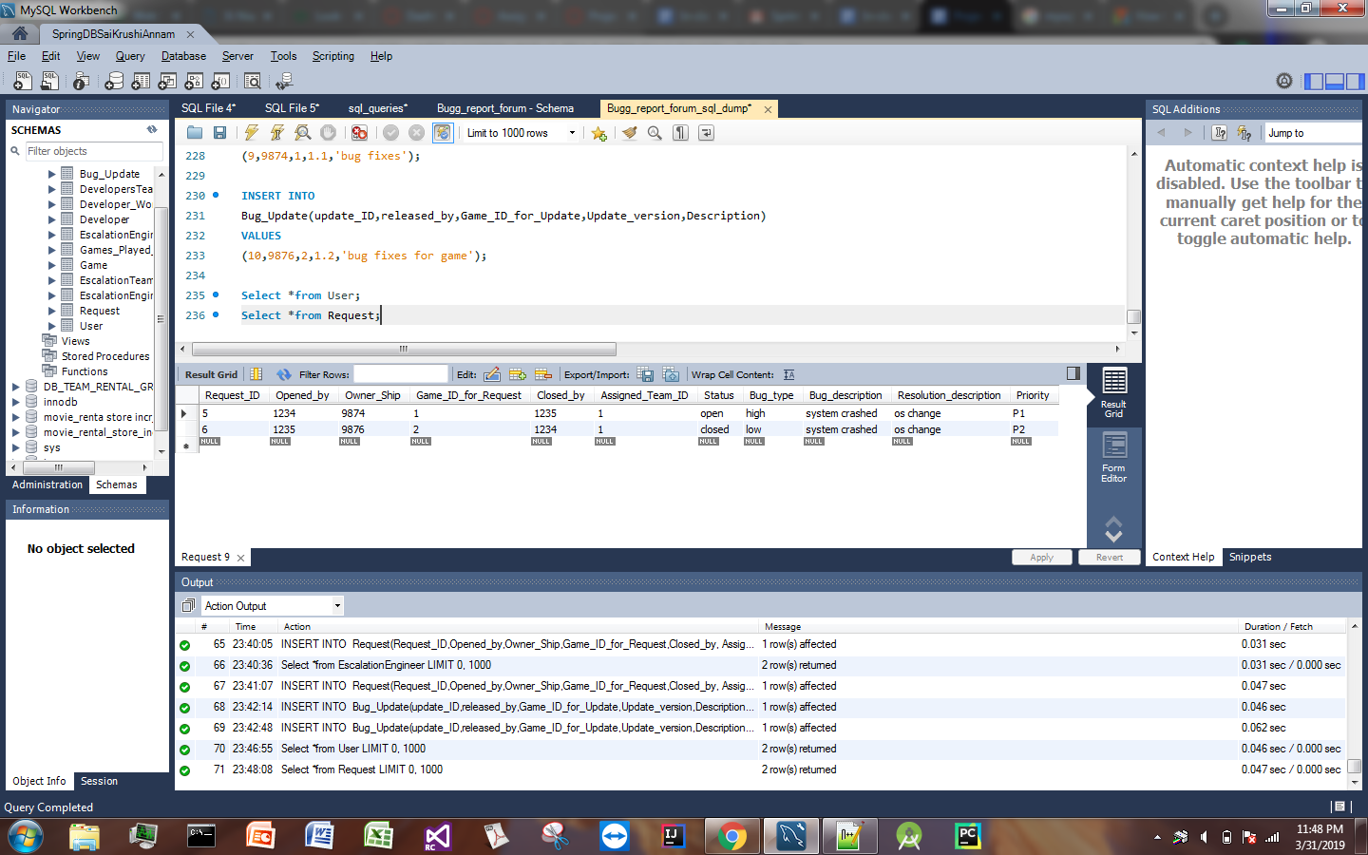

Select *from Developer;

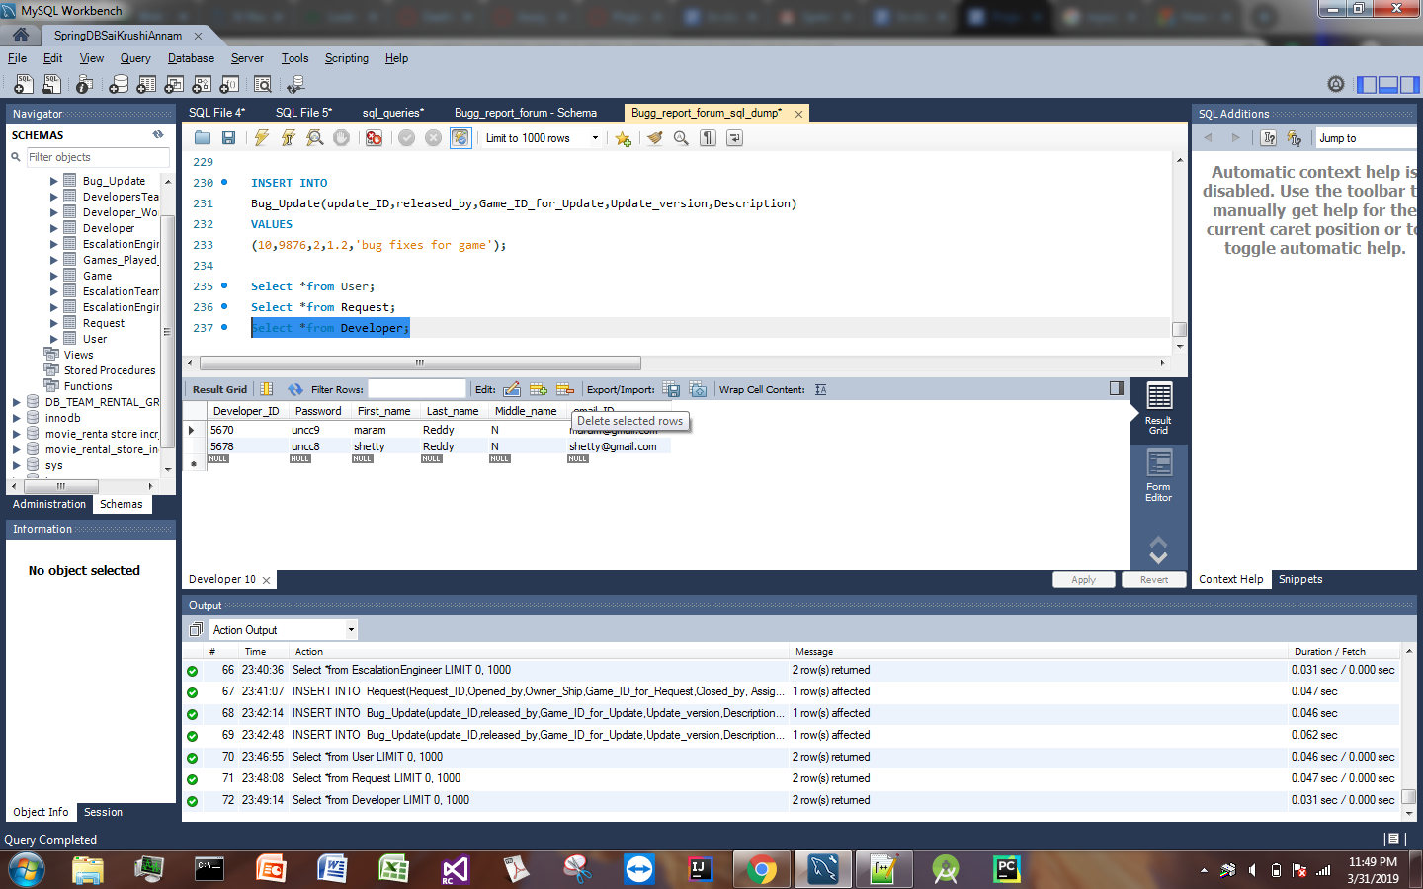

UI SCREENSHOTS:

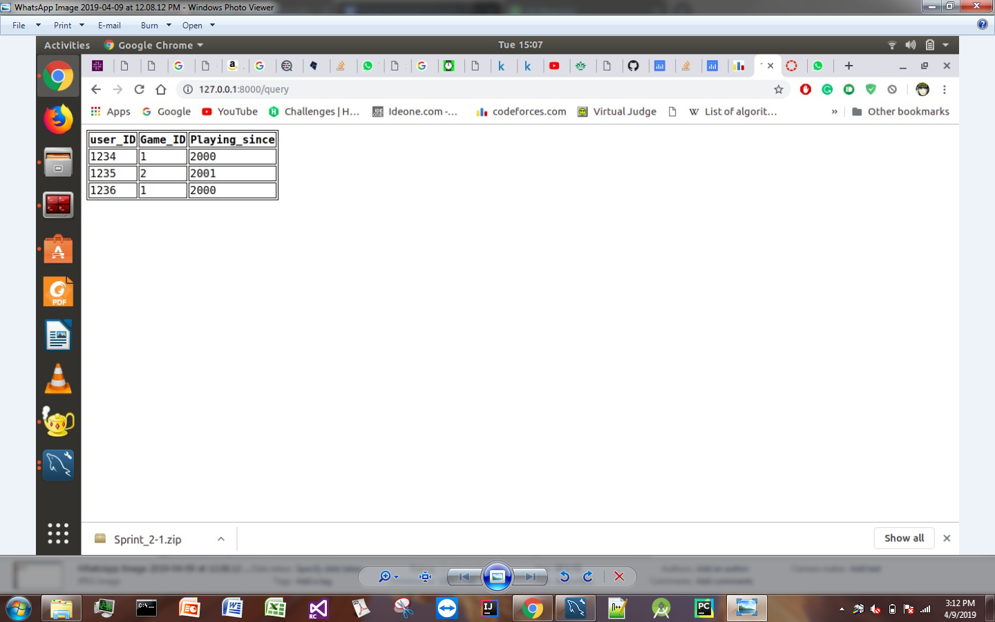

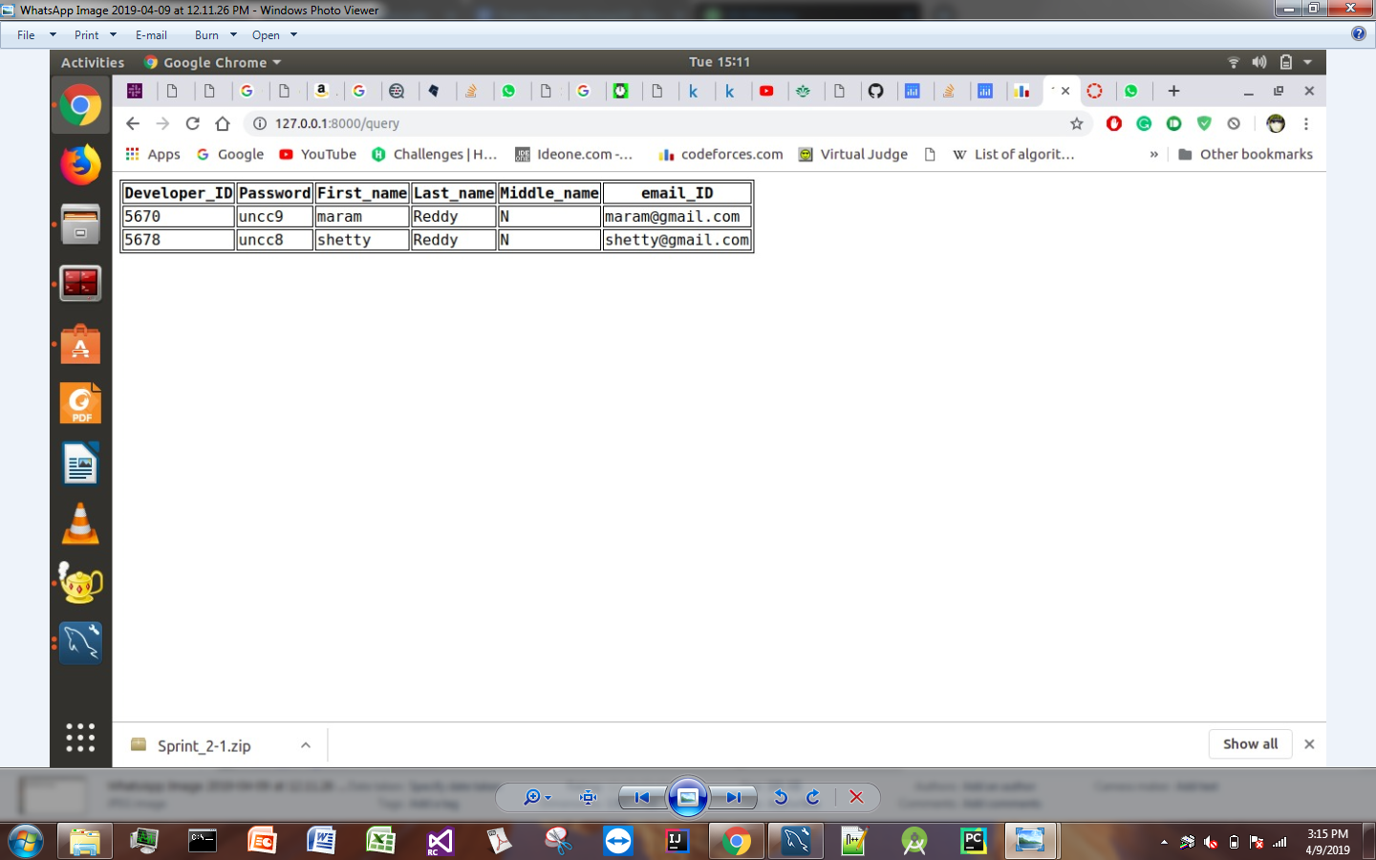

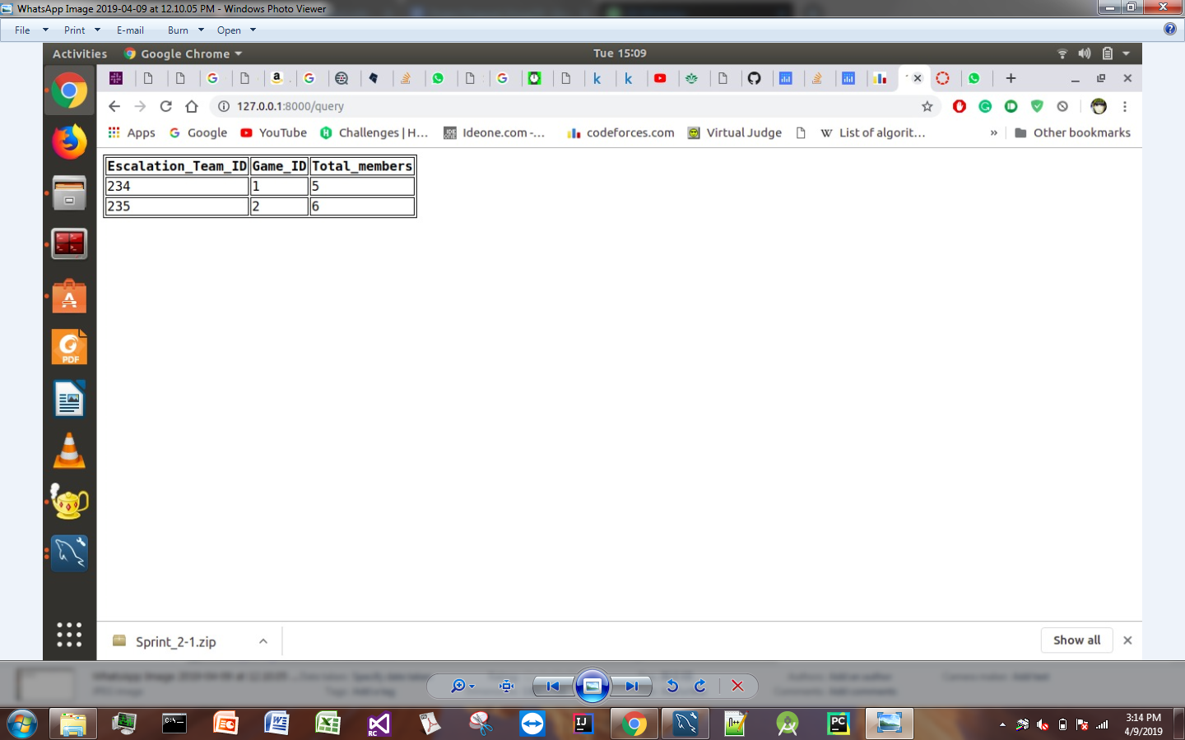

**SPRINT 3**

**User stories:**

|  |  |
| --- | --- |
| **Story ID** | **Story description** |
| User12 | As an escalation engineer i want to create a master request on all the same type of requests. |
| User13 | As a developer i will manage the master request. |

Conceptual Design:

Entity: **USER**

**Attributes:**

user_ID[Simple/Atomic]

Password[Simple/Atomic]

Name[composite]

First_name

Last_name

Middle_name

email_ID[Simple/Atomic]

Primary key justification: Every user need to have unique **user_ID**, so it is a good primary key.

Entity: **Escalation Engineer**

**Attributes:**

EscalationEngineer_ID[Simple/Atomic]

Password[Simple/Atomic]

Name[composite]

First_name

Last_name

Middle_name

email_ID[Simple/Atomic]

Primary key justification: Every Escalation Engineer need to have unique EscalationEngineer_ID, so it is a good primary key.

Entity : **Developer**

**Attributes:**

Developer_ID[Simple/Atomic]

Password[Simple/Atomic]

Name[composite]

First_name

Last_name

Middle_name

email_ID[Simple/Atomic]

Primary key justification: Every Developer need to have unique Developer_ID, so it is a good primary key.

Entity : **Escalation Team**

**Attributes:**

Escalation_Team_ID[Simple/Atomic]

Game_ID[Simple/Atomic]

Total_memebers[Simple/Atomic]

Primary key justification: Escalation_Team_ID uniquely define the Escalation Teams entity , so it is a good primary key.

Entity : **Developers Team**

**Attributes:**

Developer_Team_ID[Simple/Atomic]

Game_ID[Simple/Atomic]

Total_memebers[Simple/Atomic]

Primary key justification: Developer_Team_ID uniquely define the Developer Teams entity , so it is a good primary key.

Entity : **EscalationEngineer_Works_for**

**Attributes:**

EscalationEngineer_ID

Team_ID

Working_since

Primary key justification: EscalationEngineer_ID and Team_ID together uniquely define the EscalationEngineer_Works_for entity, so both together is a good primary key.

Entity : **Developer_Works_for**

**Attributes:**

Developer_ID

Team_ID

Working_since

Primary key justification: Developer_ID and Team_ID together uniquely define the Developer_Works_for entity , so both together is a good primary key.

Entity : **GAME**

**Attributes:**

Game_ID

Name

Platform

Publisher

Primary key justification: Every GAME need to have unique Game_ID, so it is a good primary key.

Entity : **Games_Played_by_User**

**Attributes:**

User_ID

Game_ID

Playing_since

Primary key justification: User_ID and Game_ID together uniquely define the Games_Played_by_User entity , so both together is a good primary key.

Entity : **Request**

**Attributes: Primary Key(**Request_ID)

Request_ID

Opened_by[single_valued][foreign key; references id of User table]

Owner_Ship[foreign key; references id of Escalation engineer table]

Assigned_Team_ID[foreign key; references id of Escalations team table]

Status

priority

Bug_type

Bug_description

Resolution_description

Closed_by[foreign key; references id of Escalation engineer table]

Primary key justification: Every REQUEST need to have unique Request_ID, so it is a good primary key.

Entity: **Bug_Update**

**Attributes: Primary key(**update_ID**)**

update_ID[single valued]

released_by[foreign key; references id of Escalation engineer table]

Game_ID[foreign key; references id of Game table]

Update_version

Description

Primary key justification: Every UPDATE need to have unique update_ID, so it is a good primary key.

**RelationShips:**

1. Escalation_engineer/Developer <works for> Escalation team/developer team.

Relationship: many - to - many

Participation: engineer/developer and the respective teams has total participation

In first sprint, we have assumed that each each developer/escalation engineer can work for only one game. But in this sprint we have thought about a case where, a group of developers working for a publisher can work for few games which are released under the same publisher.

So we have added new tables Developer team and Escalation team which supports only one game. We have mapped escalation engineer/developer to many teams.

2. User <raises> request

Relation : one to many

Participation: User has partial participation

Request has total participation in this relationship

Since,a request won’t exist if not raised.

3. Developer <releases>bug_ update

Relation: one to many

Participation: Developer has partial participation

Bug_update has total participation in this relationship

Here, we have assumed that a group of developers can work on an update but the update can be released by any one of them.Hence, making it a one to many relationship.

4. Escalation_engineer/developer <Updates> request

Relation : one to many.

Participation: Escalation engineer has partial participation

Request has total participation in this relationship

A request can be closed only once and a user can close many requests.

**Modifications in conceptual design:**

* We have added a new table ‘Master_Request’. This Master_Request can be created by an escalation engineer on multiple Requests of same type
* We have linked this master request table with the update table

Entity: **Master_Request**

**Attributes:**

Master_Request_ID[Simple/Atomic]

Opened_by[single_valued]

Assigned_queue[Simple/Atomic]

Update_ID

Closed_by[Simple/Atomic]

**Relationships:**

Master_Request < created on> Request

Cardinality: one to many

Participation: request has partial participation. [few requests doesn’t require Master_Request’s ]

Master_Request has total participation.

Update <included in> Master_request

Cardinality: one to one

Participation: Update has partial participation

Master_request has partial participation

**LOGICAL DESIGN:**

Table: **USER primary key(**user_ID)

user_ID

Password

First_name

Last_name

Middle_name

email_ID

Highest_normal form- 4NF

Table:**Escalation Engineer Primary Key(**EscalationEngineer_ID**)**

EscalationEngineer_ID

Password

First_name

Last_name

Middle_name

email_ID

Table:**Developer Primary Key(**Developer_ID)

Developer_ID

Password

First_name

Last_name

Middle_name

email_ID

Table: **Escalation Teams Primary Key(**Escalation_Team_ID)

Escalation_Team_ID

Game_ID[foreign key, references to Game table]

Total_members

Highest Normal Form : 4NF

Table: **Developers Teams Primary Key(**Developer_Team_ID)

Developer_Team_ID

Game_ID[foreign key, references to Game table]

Total_members

Highest Normal Form : 4NF

Table:**EscalationEngineer_Works_for**

**Primary Key(EscalationEngineer_ID,Team_ID)**

EscalationEngineer_ID[foreign key, references to **Escalation Engineer** table]

Team_ID[foreign key, references to **Escalation Teams** table]

Working_since

Highest Normal Form : 4NF

Table:**Developer_Works_for** Primary Key(Developer_ID,Team_ID)

Developer_ID[foreign key, references to **Developer** table]

Team_ID[foreign key, references to **Developer Teams** table]

Working_since

Highest Normal Form : 4NF

Table:**GAME Primary Key(**Game_ID**)**

Game_ID

Name

Platform

Publisher

Highest Normal Form : 2NF

Name → {publisher}, due to presence of transitive dependency, the highest normal form achieved is 2NF. We can normalize it more but it will result in more unnecessary tables and so will be joints.

Table:**Games_Played_by_User Primary Key(**User_ID, Game_ID**)**

User_ID[foreign key; references id of user table]

Game_ID[foreign key; references id of Game table]

Playing_since

Highest Normal Form - 4NF

Table:  **Request Primary Key(**Request_ID)

Request_ID

Opened_by[single_valued][foreign key; references id of User table]

Owner_Ship[foreign key; references id of Escalation engineer table]

Assigned_Team_ID[foreign key; references id of Escalation engineer teams table]

Status

priority

Bug_type

Bug_description

Resolution_description

Closed_by[foreign key; references id of Escalation engineer table]

* Here anyone of the 3(Escalation Engineer, Developer, User) can close the Request, so that’s the reason the “Closed_by” attribute has foreign key references to 3 tables.

Highest Normal Form - 4NF

Table: **Bug_Update Primary key(**update_ID**)**

update_ID[single valued]

released_by[foreign key; references id of Developer table][Developer ID]

Game_ID_for_Update[foreign key; references id of Game table]

Update_version

Description

Bug_Request[foreign key; references id of Request table][Request_ID]

Highest Normal Form - 4NF

**Updated Logical Design:**

Table:  **Request Primary Key(**Request_ID)

Request_ID

Master_Request_ID[Foreign key; references to Master_Request_ID of Master_Request table]

Opened_by[single_valued][foreign key; references id of User table]

Owner_Ship[foreign key; references id of Escalation engineer table]

Assigned_Team_ID[foreign key; references id of Escalation engineer teams table]

Status

priority

Bug_type

Bug_description

Resolution_description

Closed_by[foreign key; references id of Escalation engineer table]

Table:  **Master_Request Primary Key(**Master_Request_ID)

Master_Request_ID

Opened_by[single_valued][foreign key; references id of User table]

Owner_Ship[foreign key; references id of Developer table]

Assigned_Team_ID[foreign key; references id of Developer Teams table]

Resolution_description

Closed_by[foreign key; references id of Developertable]

**Indexes:**

1. **User Table:**

**Index 1**: Primary key is user_ID - Default INDEX

INDEX_NAME - user_ID (Primary Key)

<type - clustered>

**Justification**: For Primary key a default Index is created, so we need not create new INDEX on Primary Key.

**Index 2**: Index on FirstName and LastName of the User

INDEX_NAME - User_full_name

<type - Non-Clustered>

**Justification**: This gives easy search on the UserName as this avoids Table Scan when we want to search based on the name.

**Index 3**: Index on Email-ID of the User

INDEX_NAME - User_Email

<type - Non-Clustered>

**Justification**: The email_id of user also may be unique and if we create INDEX on email this gives us an easy search to identify the user.

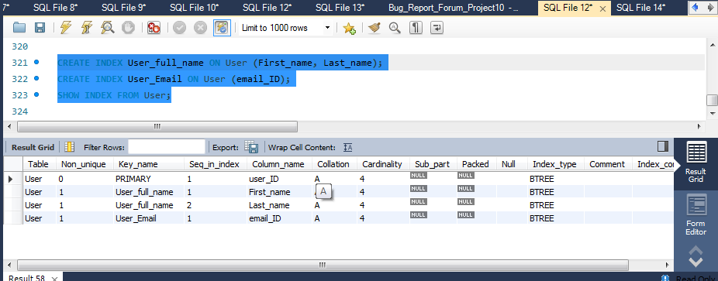

1. **Developer Table:**

**Index 1**: Primary key is Developer_ID - Default INDEX

INDEX_NAME - Developer_ID

<type - clustered>

**Justification**: For Primary key a default Index is created, so we need not create new INDEX on Primary Key.

**Index 2**: Index on FirstName and LastName of the Developer

INDEX_NAME - Developer_full_name

<type - Non-Clustered>

**Justification**: This gives easy search based on the Developer Name as this avoids Table Scan when we want to search based on the name.

**Index 3**: Index on Email-ID of the Developer

INDEX_NAME - Developer_Email_ID

<type - Non-Clustered>

**Justification**: The email_id of developer also may be unique and if we create INDEX on email this gives us an easy search to identify the Developer.

**Index 3**: Index on Salary_per_annum of the Developer

INDEX_NAME - Developer_Salary

<type - Non-Clustered>

**Justification**: When we want to search for Developers on some particular salary range then this indexing will be helpful and gets the faster results. This Index arranges the Salary in Ascending Order.

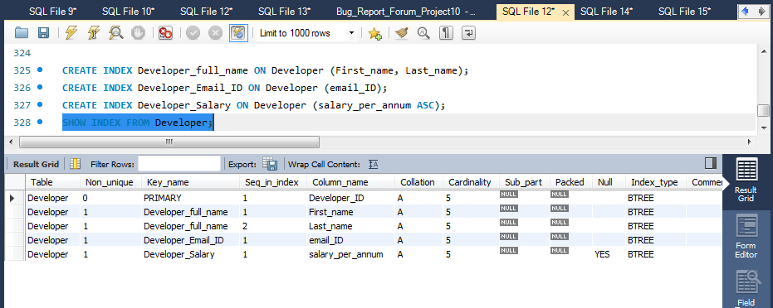

3. **EscalationEngineer Table:**

**Index 1**: Primary key is EscalationEngineer_ID - Default INDEX

INDEX_NAME - EscalationEngineer_ID

<type - Clustered>

**Justification**: For Primary key a default Index is created, so we need not create new INDEX on Primary Key.

**Index 2**: Index on FirstName and LastName of the EscalationEngineer

INDEX_NAME - EscalationEngineer_full_name

<type - Non-Clustered>

**Justification**: This gives easy search based on the EscalationEngineer Name as this avoids Table Scan when we want to search based on the name.

**Index 3**: Index on Email-ID of the EscalationEngineer

INDEX_NAME - EscalationEngineer_Email_ID

<type - Non-Clustered>

**Justification**: The email_id of Escalation engineer also may be unique and if we create INDEX on email this gives us an easy search to identify the EscalationEngineer.

**Index 3**: Index on Salary_per_annum of the EscalationEngineer

INDEX_NAME - Developer_Salary

<type - Non-Clustered>

**Justification**: When we want to search for EscalationEngineeron some particular salary range then this indexing will be helpful and gets the faster results. This Index arranges the Salary in Ascending Order.

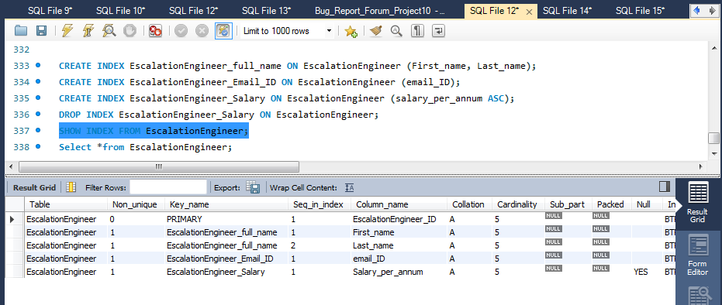

4. **Game Table:**

**Index 1**: Primary key is Game_ID - Default INDEX

INDEX_NAME - Game_ID

<type - Clustered>

**Justification**: For Primary key a default Index is created, so we need not create new INDEX on Primary Key.

**Index 2**: Index on Game Name

INDEX_NAME - Game_Name

<type - Non-Clustered>

**Justification**: This gives easy search based on the Game

Name as this avoids Table Scan when we want to search based on the name.

**Index 3**: Index on Publishers of the Game

INDEX_NAME - Game_Publisher

<type - Non-Clustered>

**Justification**: When we want to search what games are released by some particular publisher then this Index is helpful.

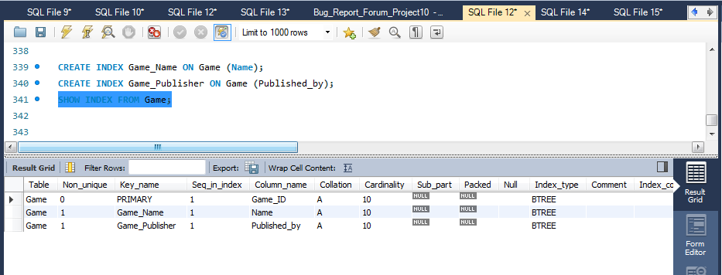

4. **DeveloperTeams Table:**

**Index 1**: Primary key is Developer_Team_ID - Default INDEX

INDEX_NAME - Developer_Team_ID

<type - Clustered>

**Justification**: For Primary key a default Index is created, so we need not create new INDEX on Primary Key.

**Index 2**: Index on Game_ID

INDEX_NAME - Game_ID

<type - Non-Clustered>

**Justification**: Game_ID is a Foreign Key which is Not Unique. This Index is used for faster searchers based on game ID like when we want to search which teams are working for particular game.

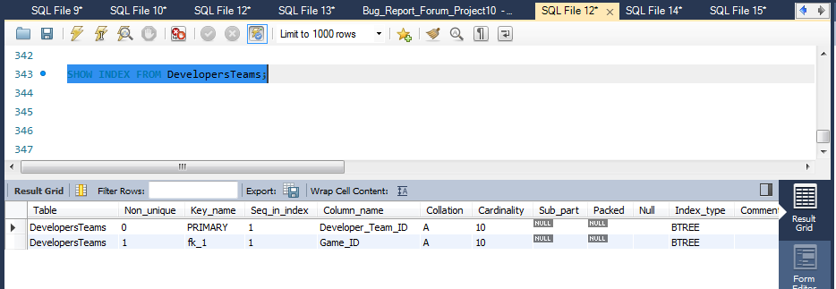

5. **EscalationTeams Table:**

**Index 1**: Primary key is Escalation_Team_ID - Default INDEX

INDEX_NAME - Game_ID

<type - Clustered>

**Justification**: For Primary key a default Index is created, so we need not create new INDEX on Primary Key.

**Index 2**: Index on Game_ID

INDEX_NAME - Game_ID

<type - Non-Clustered>

**Justification**: Game_ID is a Foreign Key which is Not Unique. This Index is used for faster searchers based on game ID like when we want to search which Escalation Engineer teams are monitoring the request for a particular game.

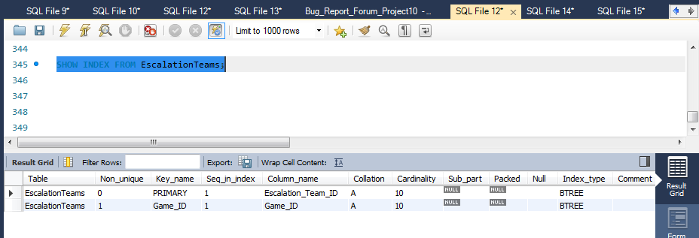

6. **Developer_Works_for Table:**

**Index 1**: Primary key is Developer_ID - Default INDEX

INDEX_NAME - Developer_ID

<type - Clustered>

**Justification**: For Primary key a default Index is created, so we need not create new INDEX on Primary Key.

**Index 2**: Index on Team_ID

INDEX_NAME - Team_ID

<type - Clustered>

**Justification**: For Primary key a default Index is created, so we need not create new INDEX on Primary Key.

**Index 3**: Index on Working_since

INDEX_NAME - Developer_WorkingPeriod

<type - Non-Clustered>

**Justification**: When we want to make search regarding the developers working for some particular period then this INDEX is helpful. This Index arranges the Salary in Ascending Order.

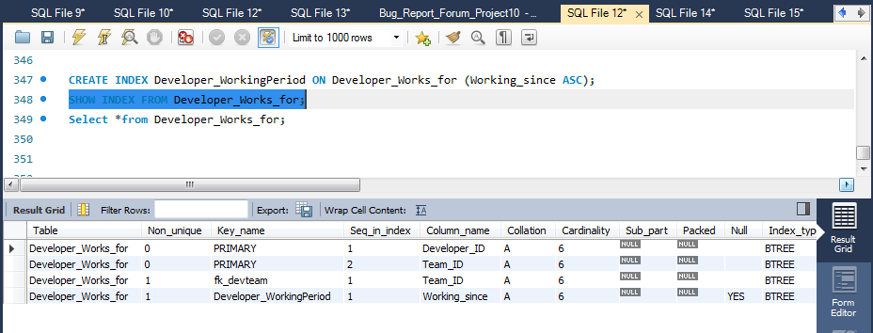

7. **EscalationEngineer_Works_for Table:**

**Index 1**: Primary key is EscalationEngineer_ID - Default INDEX

INDEX_NAME - EscalationEngineer_ID

<type - Clustered>

**Justification**: For Primary key a default Index is created, so we need not create new INDEX on Primary Key.

**Index 2**: Index on Team_ID

INDEX_NAME - Team_ID

<type - Clustered>

**Justification**: For Primary key a default Index is created, so we need not create new INDEX on Primary Key.

**Index 3**: Index on Working_since

INDEX_NAME - Escalation_WorkingPeriod

<type - Non-Clustered>

**Justification**: When we want to make search regarding the Escalation Engineers working for some particular period then this INDEX is helpful. This Index arranges the Salary in Ascending Order.

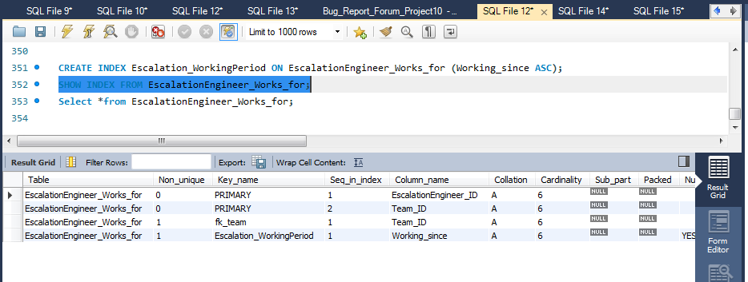

8. **Games_Played_by_User Table:**

**Index 1**: Primary key is user_ID - Default INDEX

INDEX_NAME - user_ID

<type - Clustered>

**Justification**: For Primary key a default Index is created, so we need not create new INDEX on Primary Key.

**Index 2**: Index on Game_ID

INDEX_NAME - Game_ID

<type - Clustered>

**Justification**: For Primary key a default Index is created, so we need not create new INDEX on Primary Key.

**Index 2**: Index on Playing_since

INDEX_NAME - User_PlayingPeriod

<type - Non-Clustered>

**Justification**: To know from which year or time the user is playing a particular game, basically this index is helpful to get information on games which are played for some particular period. So to such information this index is created. This index arranges the time in ascending order.

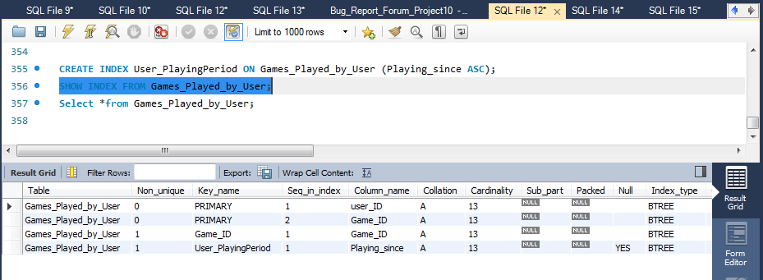

9. **Bug_Update Table:**

**Index 1**: Primary key is update_ID - Default INDEX

INDEX_NAME - update_ID

<type - Clustered>

**Justification**: For Primary key a default Index is created, so we need not create new INDEX on Primary Key.

**Index 2**: Index on released_by

INDEX_NAME - released_by

<type - Non-Clustered>

**Justification**: released_by is foreign key for this table which refers to Developer_ID of the Developer Table. When there are joins then this index helps in faster scanning of tables to fetch data and impact performance when the primary key value is updated, or if the row is deleted.

**Index 3**: Index on Game_ID_for_Update

INDEX_NAME - Game_ID_for_Update

<type - Non-Clustered>

**Justification**: Game_ID_for_Update is foreign key for this table which refers to Game_ID of the Game Table. When there are joins then this index helps in faster scanning of tables to fetch data and impact performance when the primary key value is updated, or if the row is deleted.

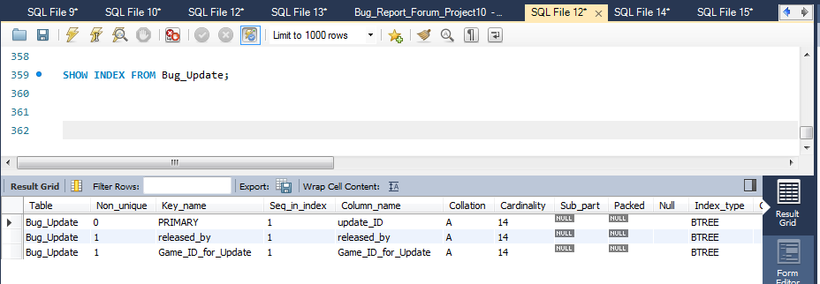

10. **Master_Request Table:**

**Index 1**: Primary key is Master_Request_ID - Default INDEX

INDEX_NAME - Master_Request_ID

<type - Clustered>

**Justification**: For Primary key a default Index is created, so we need not create new INDEX on Primary Key.

**Index 2**: Index on Owner_Ship

INDEX_NAME - Owner_Ship

<type - Non-Clustered>

**Justification**: Owner_Ship is foreign key for this table which refers to Developer_ID of the Developer Table. When there are joins then this index helps in faster scanning of tables to fetch data and impact performance when the primary key value is updated, or if the row is deleted.

**Index 3**: Index on Closed_by

INDEX_NAME - Closed_by

<type - Non-Clustered>

**Justification**: Closed_by is foreign key for this table which refers to Developer_ID of the Developer Table. When there are joins then this index helps in faster scanning of tables to fetch data and impact performance when the primary key value is updated, or if the row is deleted.

**Index 4**: Index on update_ID

INDEX_NAME - update_ID

<type - Non-Clustered>

**Justification**: update_ID is foreign key for this table which refers to update_ID of the Bug_Update Table. When there are joins then this index helps in faster scanning of tables to fetch data and impact performance when the primary key value is updated, or if the row is deleted.

**Index 5**: Index on Opened_by

INDEX_NAME - Opened_by

<type - Non-Clustered>

**Justification**: Opened_by is foreign key for this table which refers to EscalationEngineer_ID of the EscalationEngineer Table. When there are joins then this index helps in faster scanning of tables to fetch data and impact performance when the primary key value is updated, or if the row is deleted.

**Index 6**: Index on Assigned_Team_ID

INDEX_NAME - Assigned_Team_ID

<type - Non-Clustered>

**Justification**: Assigned_Team_IDis foreign key for this table which refers to Developer_Team_ID of the DeveloperTeams Table. When there are joins then this index helps in faster scanning of tables to fetch data and impact performance when the primary key value is updated, or if the row is deleted.

**Index 7**: Index on Time_created

INDEX_NAME - Master_Request_CreatedTime

<type - Non-Clustered>

**Justification**: To know from which year(Date) or time this particular Master_Request is created, basically this index is helpful to get information on Master Requests which are created by Escalation Engineers. So to such information this index is created. This index arranges the time in ascending order.

**Index 8**: Index on Status

INDEX_NAME - Master_Request_Status

<type - Non-Clustered>

**Justification**: When we make searches based on the status that means to fetch the requests which are in open or closed or work-in-progress condition then this index is useful.

**Index 9**: Index on Priority

INDEX_NAME - Master_Request_Priority

<type - Non-Clustered>

**Justification**: For searches which involves Priority of the Bug then this index is useful.

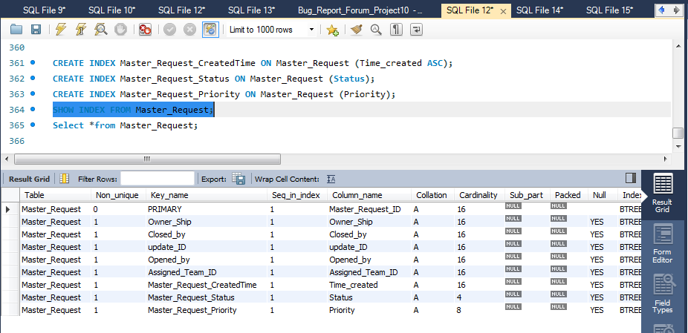

11. **Request Table:**

**Index 1**: Primary key is Request_ID - Default INDEX

INDEX_NAME - Request_ID

<type - Clustered>

**Justification**: For Primary key a default Index is created, so we need not create new INDEX on Primary Key.

**Index 2**: Index on Owner_Ship

INDEX_NAME - Owner_Ship

<type - Non-Clustered>

**Justification**: Owner_Ship is foreign key for this table which refers to EscalationEngineer_ID of the EscalationEngineer Table. When there are joins then this index helps in faster scanning of tables to fetch data and impact performance when the primary key value is updated, or if the row is deleted.

**Index 3**: Index on Closed_by

INDEX_NAME - Closed_by

<type - Non-Clustered>

**Justification**: Closed_by is foreign key for this table which refers to EscalationEngineer_ID of the EscalationEngineer Table. When there are joins then this index helps in faster scanning of tables to fetch data and impact performance when the primary key value is updated, or if the row is deleted.

**Index 4**: Index on Master_Request_ID

INDEX_NAME - Master_Request_ID

<type -Non-Clustered>

**Justification**: Master_Request_ID is foreign key for this table which refers to Master_Request_ID of the Master_Request Table. When there are joins then this index helps in faster scanning of tables to fetch data and impact performance when the primary key value is updated, or if the row is deleted.

**Index 5**: Index on Opened_by

INDEX_NAME - Opened_by

<type - Non-Clustered>

**Justification**: Opened_by is foreign key for this table which refers to user_ID of the User Table. When there are joins then this index helps in faster scanning of tables to fetch data and impact performance when the primary key value is updated, or if the row is deleted.

**Index 6**: Index on Assigned_Team_ID

INDEX_NAME - Assigned_Team_ID

<type - Non-Clustered>

**Justification**: Assigned_Team_ID is foreign key for this table which refers to EscalationEngineer_Team_ID of the EscalationTeams Table. When there are joins then this index helps in faster scanning of tables to fetch data and impact performance when the primary key value is updated, or if the row is deleted.

**Index 7**: Index on Time_created

INDEX_NAME - Request_CreatedTime

<type - Non-Clustered>

**Justification**: To know from which year(Date) or time this particular Master_Request is created, basically this index is helpful to get information on Master Requests which are created by Escalation Engineers. So to such information this index is created. This index arranges the time in ascending order.

**Index 8**: Index on Status

INDEX_NAME - Request_Status

<type - Non-Clustered>

**Justification**: When we make searches based on the status that means to fetch the requests which are in open or closed or work-in-progress condition then this index is useful.

**Index 9**: Index on Priority

INDEX_NAME - Request_Priority

<type - Non-Clustered>

**Justification**: For searches which involves Priority of the Bug then this index is useful.

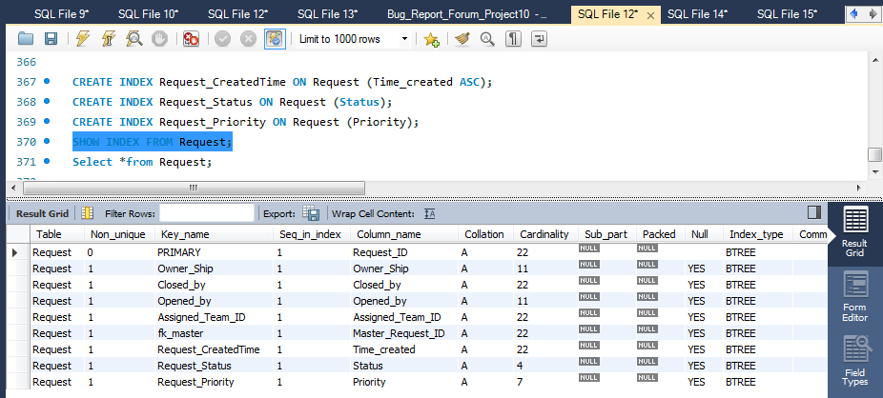

***VIEWS AND STORED PROGRAMS***

1. **Stored procedure**: <Request_Details>

DELIMITER $$

USE `Bug_Report_Forum_Project10`$$

CREATE PROCEDURE `Request_Details` (IN Request_ID varchar(20))

BEGIN

Select t1.Request_ID,t2.EscalationEngineer_ID,t4.Developer_ID,t6.Game_ID,t6.Name Game_Name,t1.Priority,

t1.Status,t5.update_ID,t5.Description Bug_description

from Request t1

INNER JOIN EscalationEngineer t2 ON t2.EscalationEngineer_ID = t1.Owner_Ship

INNER JOIN Master_Request t3 ON t3.Master_Request_ID = t1.Master_Request_ID

INNER JOIN Developer t4 ON t4.Developer_ID = t3.Owner_Ship

INNER JOIN Bug_Update t5 ON t5.update_ID = t3.update_ID

INNER JOIN Game t6 ON t6.Game_ID = t1.Game_ID_for_Request

WHERE t1.Request_ID = Request_ID;

END$$

DELIMITER ;

**Parameters -** Input parameter is Request_ID

Output we are displaying the relevant details like developer,escalation engineer working on the request, status, game etc.

**Goal :** The main idea is to fetch the details of any request from the user.

EXECUTION OF STORED_PROCEDURE:

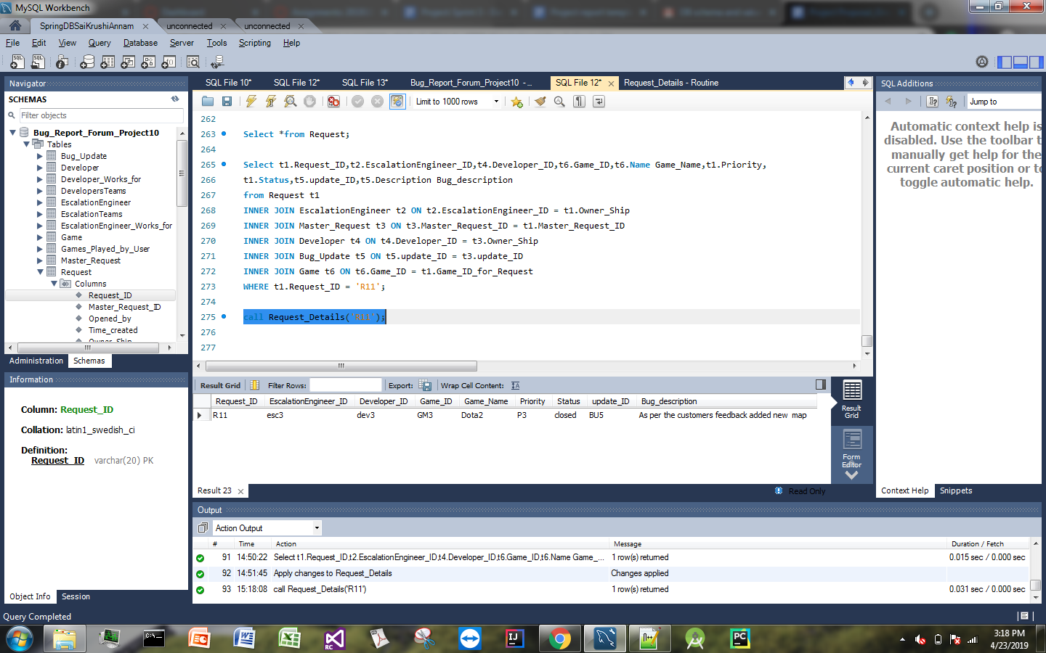

2. **Stored procedure**:<Developer_Details>

DELIMITER $$

USE `Bug_Report_Forum_Project10`$$

CREATE PROCEDURE `Developer_Details` (IN Developer_ID varchar(15))

BEGIN

Select t1.Developer_ID,concat(t1.First_name,' ',t1.Middle_name,' ',t1.Last_name) Developer_name,t2.Team_ID Team,

t4.Game_ID,t4.Name Game_Name,t6.Request_ID,t2.Working_since

from Developer t1

INNER JOIN Developer_Works_for t2 On t2.Developer_ID = t1. Developer_ID

INNER JOIN DevelopersTeams t3 ON t3.Developer_Team_ID = t2.Team_ID

INNER JOIN Game t4 ON t4.Game_ID = t3.Game_ID

INNER JOIN Games_Played_by_User t5 ON t5.Game_ID = t4.Game_ID

INNER JOIN Request t6 ON t6.Opened_by = t5.user_ID

WHERE t1.Developer_ID = Developer_ID

ORDER BY t6.Request_ID;

END$$

DELIMITER ;

**Parameters -** Input parameter is Developer_ID

Output we are displaying the relevant details like developer Name, Team, Game_ID, Game Name, Working Since.

**Goal :** The main idea is to fetch the details of any developer and to know what requests he/she is working upon and from which date they are working on the Request.

EXECUTION OF STORED_PROCEDURE:

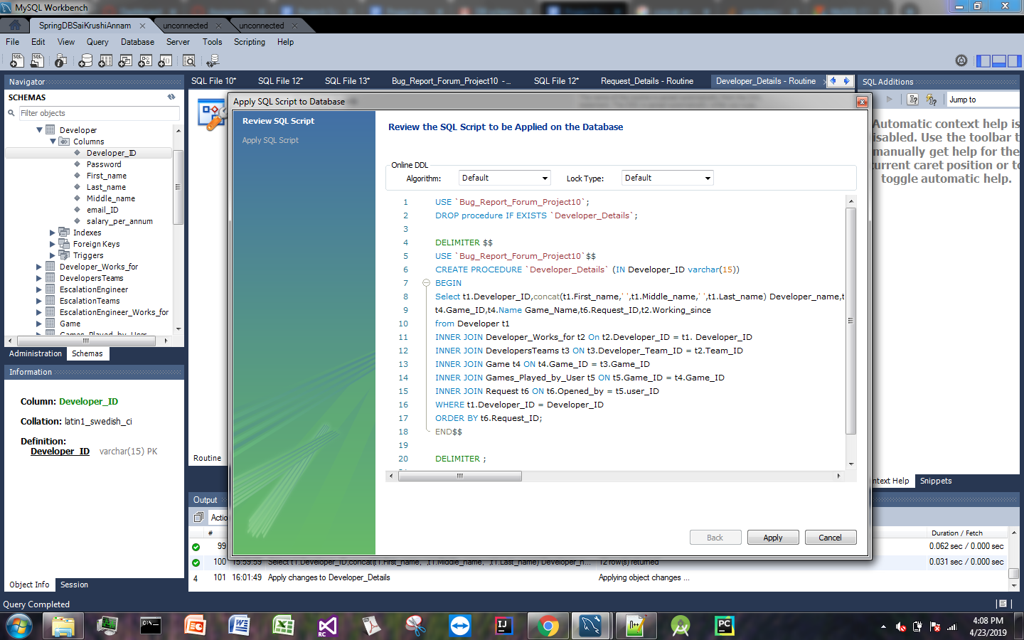

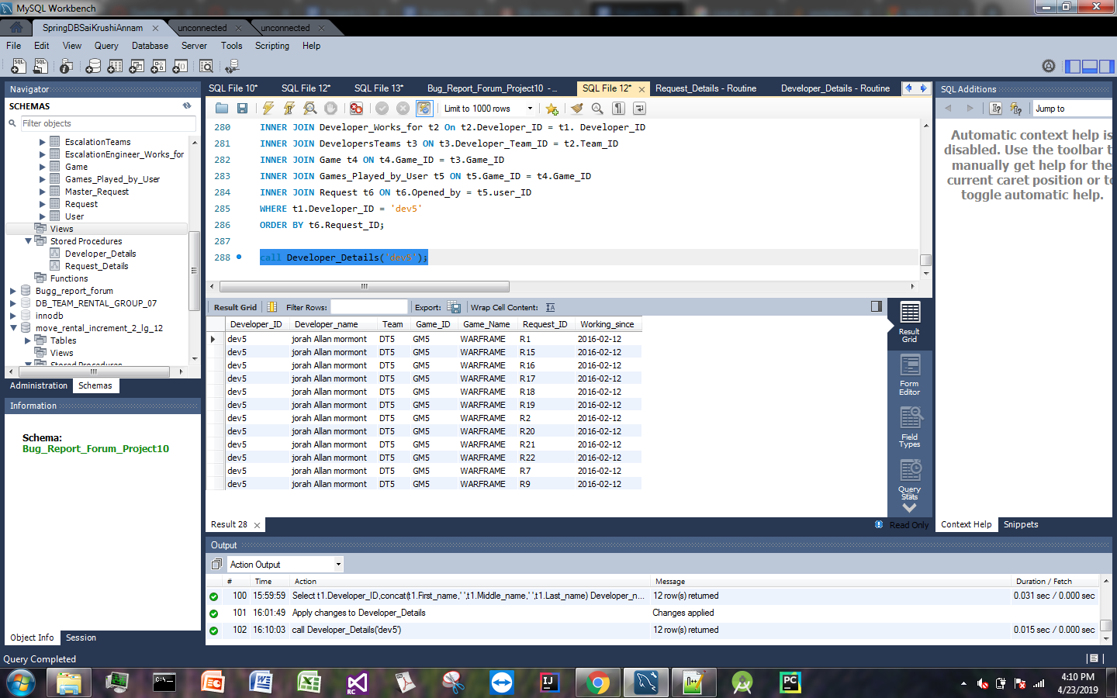

**VIEWS:**

**View1**: <Request_Details>

Goal: <This view is used to fetch details of any request in the request table, with this we can get details of which request are opened by which user and closed by which escalation Engineer and its status. This can be used by Escalation engineer for request management.

CREATE VIEW Request_Details AS

Select Request_ID,Opened_by,Closed_by,Status from Request;

Select *from Request_Details;

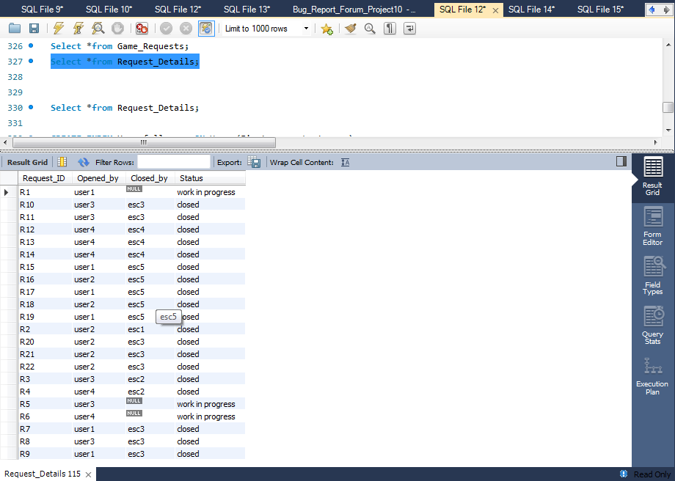

**View2**: <Game_Requests>

Goal: <This view is used to fetch details regarding the number of requests raised for same game_ID, this is used by escalation-engineers to know the count of requests raised on one specific game.>

CREATE VIEW Game_Requests AS

Select t1.Game_ID,t1.Name Game_Name,count(t2.Request_ID) Number_of_Requests

from Game t1

INNER JOIN Request t2 ON t2.Game_ID_for_Request = t1.Game_ID

Where t1.Game_ID = 'GM5'

GROUP BY (t1.Game_ID);

Select *from Game_Requests;

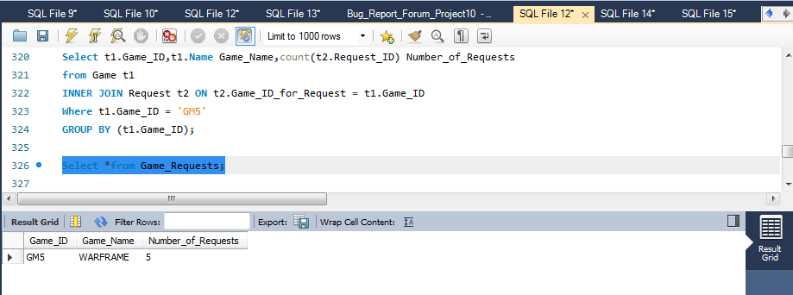

**View3**: <User_EscalationEngineer_View>

Goal: <This view is used to fetch details regarding the requests raised by user for which games and their updates, this is used by escalation-engineers to know about the different requests raised by different user.>

CREATE VIEW User_EscalationEngineer_View AS

Select t1.user_ID, concat(t1.First_name,' ',t1.Middle_name,' ',t1.Last_name) User_name,t2.Request_ID, t2.Status,

t2.Priority, t2.Time_created, t3.Game_ID, t3.Name Game_Name, t4.update_ID, t4.released_by

from User t1

INNER JOIN Request t2 ON t2.Opened_by = t1.user_ID

INNER JOIN Game t3 ON t3.Game_ID = t2.Game_ID_for_Request

INNER JOIN Bug_Update t4 ON t4.Game_ID_for_Update = t3.Game_ID

Where t1.user_ID = 'user1'

GROUP BY (Request_ID);

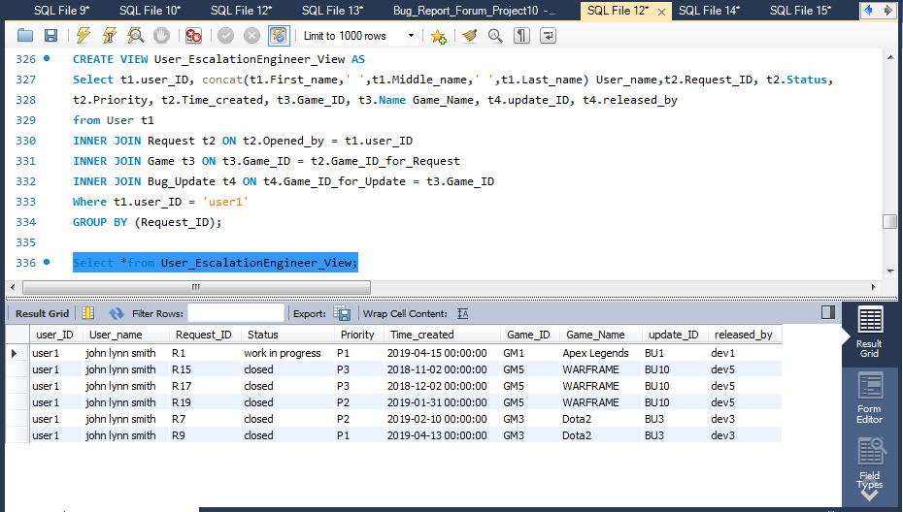

**Trigger**:

**Trigger 1:**

<After Insertion Trigger - DML Trigger> on <Request Table>

**Goal**: This Trigger automatically set the Last_modified field to the current timestamp before inserting the data into Request Table.

DELIMITER $$

CREATE TRIGGER after_request_insert

before insert ON request

FOR EACH ROW

BEGIN

SET

new.Last_modified = current_timestamp();

END $$

DELIMITER ;

INSERT INTO Request values('R23','MR17','user2','2019-03-09','esc4','2019-08-31',

'GM8','esc3','ET8','closed','keybord issue','UI issue','Refer master request','P2');

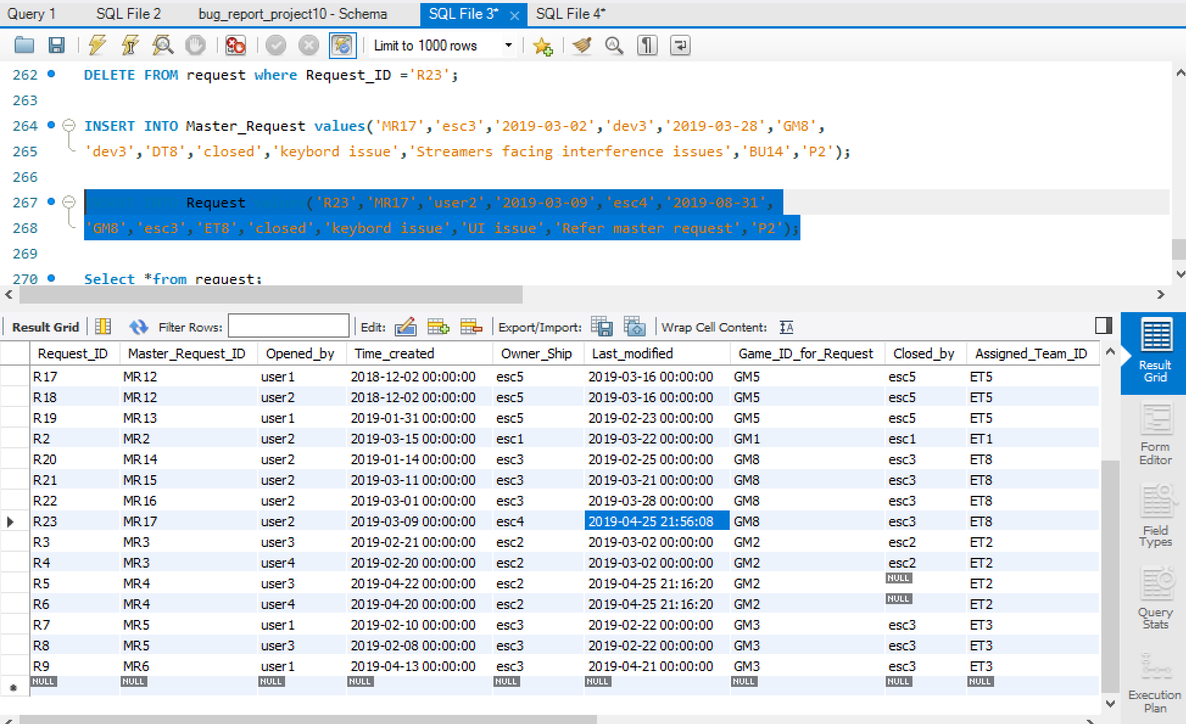

**Trigger 2:**

<Update a row - DML Trigger> on <Master_Request Table>

**Goal**: This Trigger automatically sets the value of status field as ‘closed’ in the Request table when the Master_Request is closed.

DELIMITER $$

CREATE TRIGGER after_update_master_request

after update ON master_request

FOR EACH ROW

BEGIN

if new.status="closed" then

update request set status="closed" where Master_Request_ID=new.Master_Request_ID;

end if;

END $$

DELIMITER ;

TRIGGER EXPLANATION:

Before Updating: Master_Request Table

Request Status is in Work-in-Progress

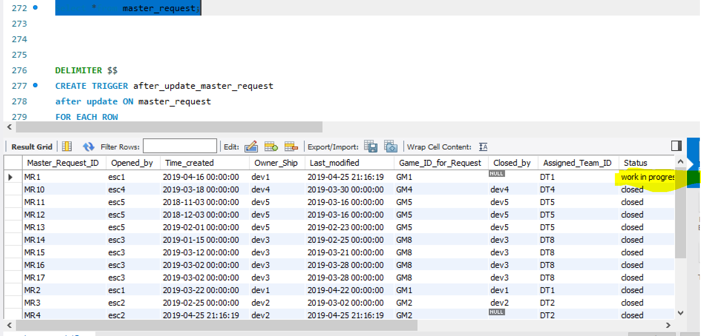

Before Updating: Request Table

Request Status is in Work-in-Progress

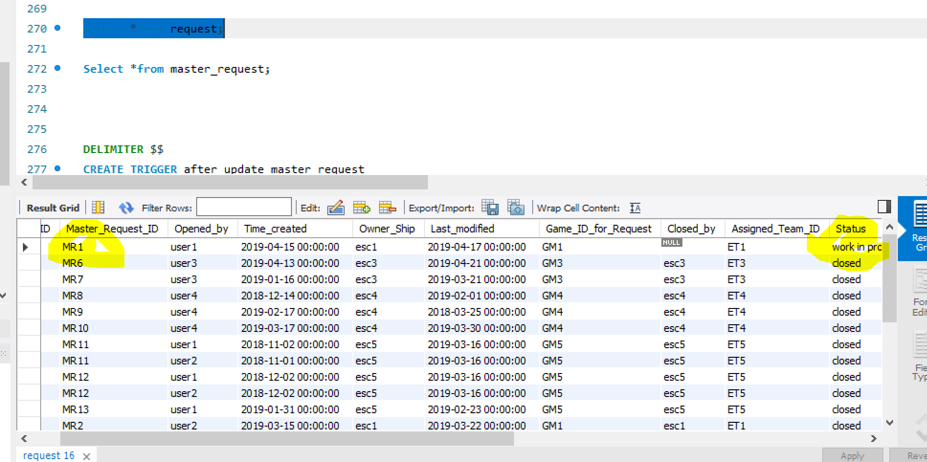

After Updating the Master_Request Table:

UPDATE master_request set status="closed" where Master_Request_ID="MR1";

After Updating: Request Table

Request Status is in ‘closed’

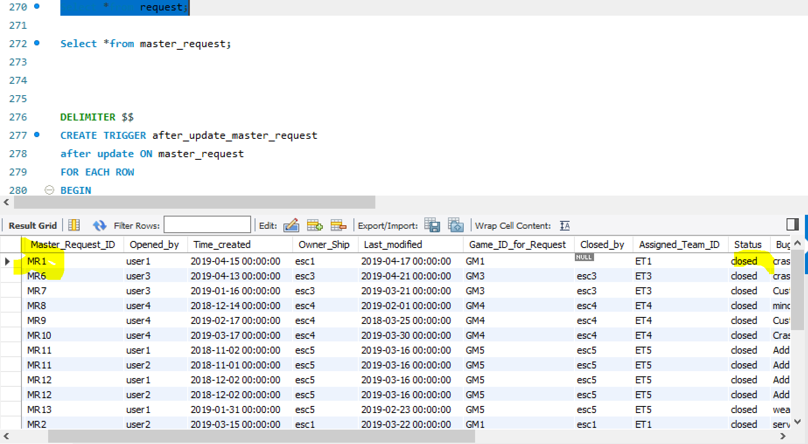

**Events**:

Event 1: Last_modified_Deletion

DELIMITER $$

CREATE EVENT Last_modified_Deletion

ON SCHEDULE EVERY 1 day

STARTS CURRENT_TIMESTAMP

DO

BEGIN

DELETE FROM Master_Request

WHERE Last_modified < DATE_SUB(curdate(), INTERVAL 365 DAY);

END$$

DELIMITER ;

EVENT_TYPE:

<DELETE ROW Event - DDL EVENT>

**Goal**: This event deletes the rows in the Master_Request Table when Last_modified date is more than a year.

Event 2: Last_modified_Deletion_Request

DELIMITER $$

CREATE EVENT Last_modified_Deletion_Request

ON SCHEDULE EVERY 1 day

STARTS CURRENT_TIMESTAMP

DO

BEGIN

DELETE FROM Request

WHERE Last_modified < DATE_SUB(curdate(), INTERVAL 365 DAY);

END$$

DELIMITER ;

EVENT_TYPE:

<DELETE ROW Event - DDL EVENT>

**Goal**: This event deletes the rows in the Request Table when Last_modified date is more than a year.